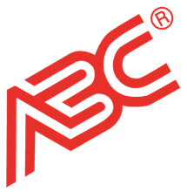

ABC Flyer Program Flipbook Links
  - National Restaurant Supply

Please Note: Flipbook links include (1)-year of hosting.

2023 Trendsetters
- Flipbook: https://fsead.com/abc/trends2023/nrs/index.html
- Cover Icon: https://fsead.com/abc/trends2023/nrs/icon.png

2023 Libbey Fall
- Flipbook: https://fescreative.com/abc/libbeyfall/nrs/index.html
- Cover Icon: https://fescreative.com/abc/libbeyfall/nrs/icon.png

